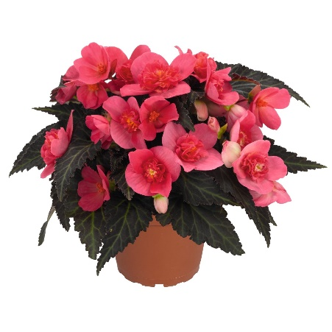
2026 Competition Plants

Begonia I’Conia First Kiss Hot Pink
Semi-double, Semi-upright and
Double Begonia which is heat tolerant.
Grow in semi-shade

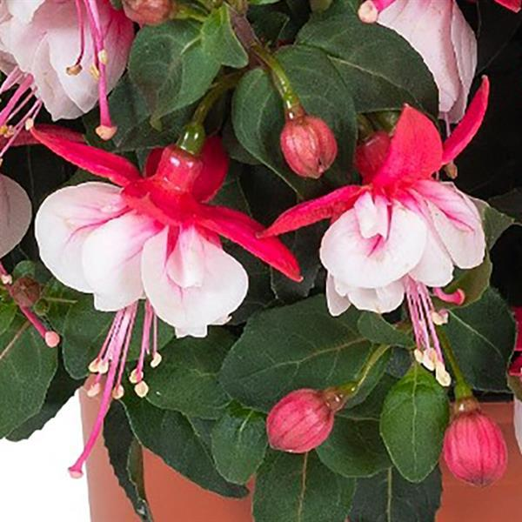
Fuchsia Ballerina ‘Arabesque’
Daylight neutral, Upright, 12 to 14 inches tall,
Grow in semi-shade.
Bred by Lieke De Mulder from Dümmen Orange

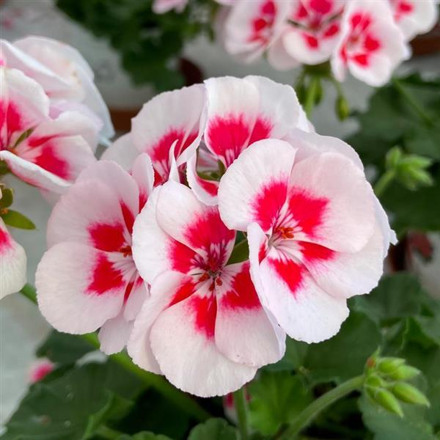
Geranium Sunrise White plus Zest
Upright, 12 to 14 inches,
Heat tolerant, Early flowering
Breeder Selecta One

